Ideation Phase
Empathize & Discover

Date | 23 September 2026
Team ID | SWTID-2026-9722
Project Name | AI Weatherwise

The Empathy Canvas for AI WeatherWise captures the behavioral patterns, attitudes, and emotional needs of everyday travelers and active individuals who struggle to interpret raw weather metrics into practical decision-making. Standard weather applications typically present numerical data—such as temperature, humidity percentages, and wind speeds—without explaining how those metrics actually feel or what actions a person should take. By mapping out what users Think & Feel, Hear, See, and Say & Do, the canvas focuses development around bridging the gap between raw data and personalized daily planning.

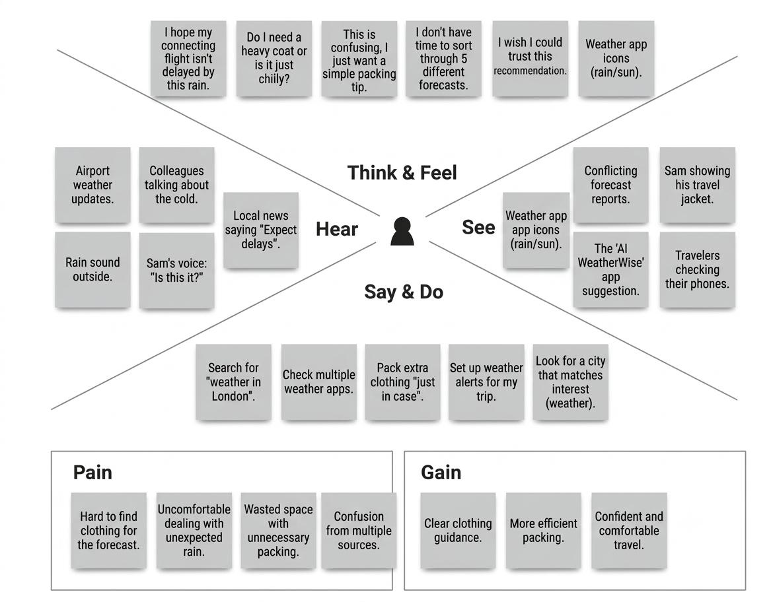
In terms of internal experience (Think & Feel), users often express anxiety about underpacking, wearing uncomfortable attire, or getting caught in unexpected rain. They see conflicting weather reports across multiple mobile tools and hear varied opinions from news sources or local peers, leading to decision paralysis. In response (Say & Do), they spend unnecessary time checking multiple forecast providers and routinely pack extra clothing "just in case," resulting in inefficient travel and cluttered luggage.
The canvas highlights the core user Pains—such as confusion caused by raw percentages, wasted packing space, and discomfort from unexpected weather changes—alongside the desired Gains, which center on receiving clear, actionable clothing guidance and feeling confident when stepping outside. This empathetic understanding directly informed the AI WeatherWise architecture: integrating the Gemini API to transform technical weather outputs into concise, human-readable clothing and activity recommendations, backed by a rule-based fallback system to ensure uninterrupted guidance.

